**Assignment:**

Create a real-time drag & drop board game.

We need to open multiple browsers to define a user in the team each team will view all team members movement

**Team 1:**

Player 1: <http://localhost:3000/?team_id>=1&user_id=1

Player 2: <http://localhost:3000/?team_id>=1&user_id=2

**Team 2:**

Player 3: <http://localhost:3000/?team_id>=2&user_id=3

Player 4: <http://localhost:3000/?team_id>=2&user_id=4

In the above example, we need player 1 and player 2 to view each other movements and actions, and player 3 and player 4 view their movements only.

Keep the history of players movements when refreshing any page the last state of the board should be kept.

**Technologies to use:**

* NodeJS - ExpressJS
* ReactJS
* Socket.io
* React drag and drop library
* MongoDB

**Steps:**

* Convert attached XD file to ReactJS project
* Start use React drag and drop
* Build socket.io project for real-time communication **(Plus)**
* Save board state to MongoDB or Browser local storage
* Fetch board state from MongoDB or Browser local storage when refreshing the page

**Plugins:**

* React DnD

<https://react-dnd.github.io/react-dnd/about>

* Socket.io (for real-time)

https://socket.io/

**Drag & Drop Explanation:**

This assignment has 2 types of draggable component “Container” and “Coin”, look at the below image:

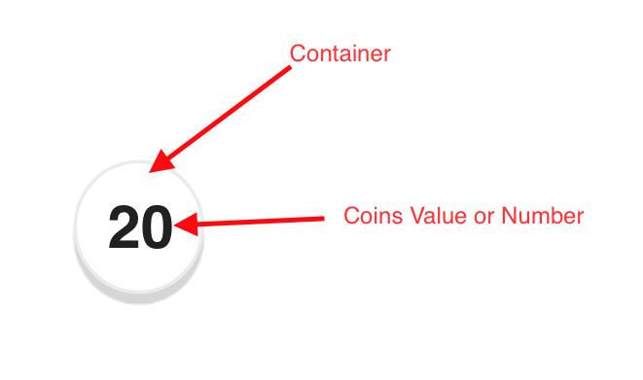

We should be able to drag either container of coins when dragging the container all coins value will be attached to it, but when we start to drag coin value its value should be 1 and leave other values in the same position (container)

**Example:**

In the above image, the container has 20 coins dragging container will move all 20 coins inside it, but when we drag the coin from the number itself the value dragged is 1 and the other 19 coins will be in the same container

When drop container on another container the droppable container will sum its coins with the dragged container coins or the coin value if we dragged only 1 coin.